Wireshark Lab 7-1

202022300317 杨业昶

## Step 1: Capture a Trace

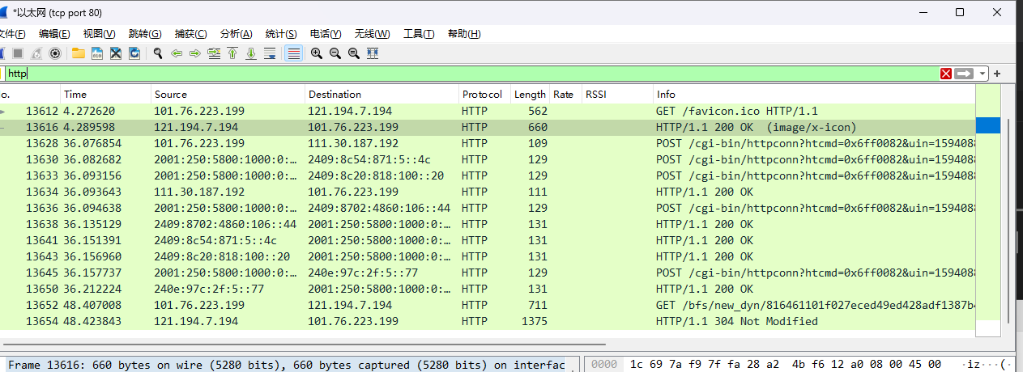

## Step 2: Inspect the Trace

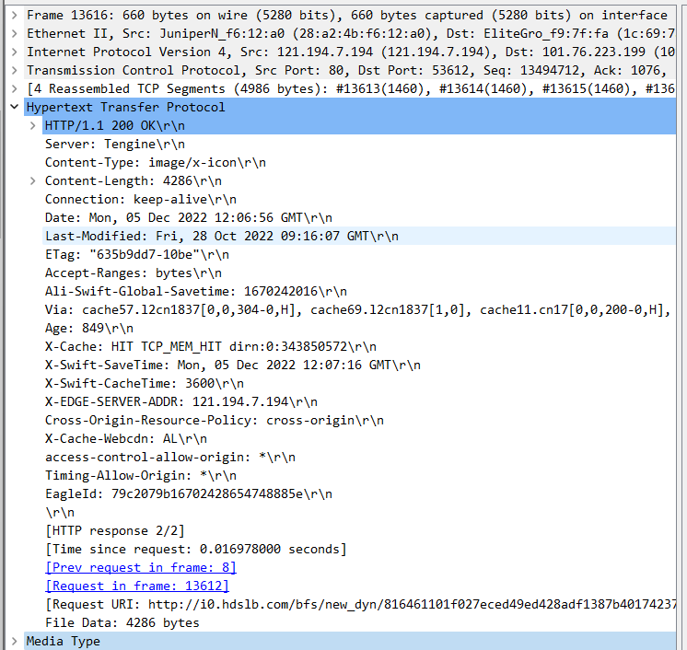

What is the format of a header line? Give a simple description that fits the headers you see.

>>>

What headers are used to indicate the kind and length of content that is returned in a response?

>>>Content-Type, Content-Length

## Step 3: Content Caching

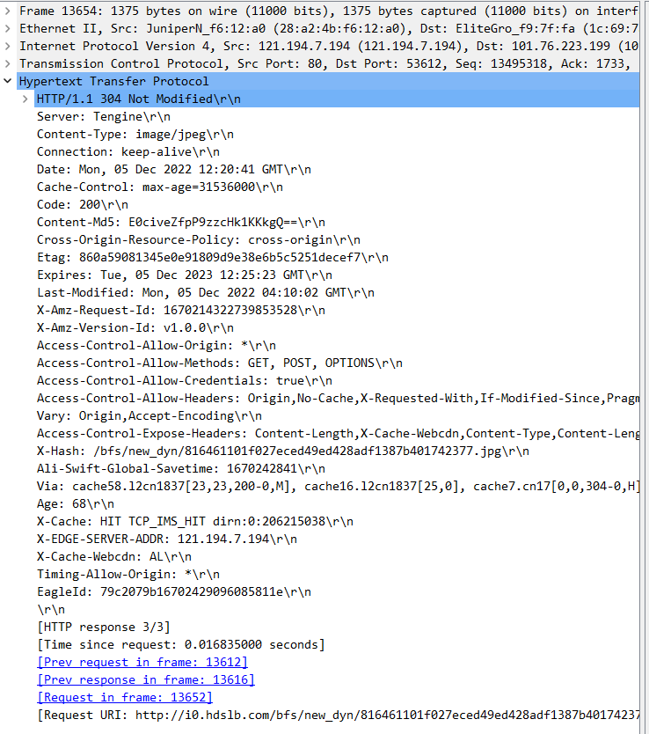

What is the name of the header the browser sends to let the server work out whether to send fresh content?

>>> Cache-Control: max-age=0\r\n

Where exactly does the timestamp value carried by the header come from?

>>> If-Modified-Since

## Step 4: Complex Pages

